**Kids Zone**

**E-PROJECT**

**DEVELOPER GUIDE**

|  |  |  |
| --- | --- | --- |
| **Supervisor.** | **Miss Qurat Ul Ain** | |
| **Batch.** | **2406E1** | |
| **Group.** | **D** | |
| **Serial No.** | **Enrollment Number** | **Student Name** |
| 1. | 1583638 | MIDHAT HANIF |
| 2. | 1579417 | ALIZA HABIB |
| 3. | 1581077 | HIFZA |
| 4. | 1579426 | MAHNOOR |

**Kids Zone**

**INTRODUCTION**

The **Kids-Zone** website is designed to offer an interactive and engaging learning experience for young children, particularly toddlers. It focuses on teaching foundational concepts like the alphabet, with each letter associated with objects (e.g., A for Apple, B for Ball), to enhance letter recognition. The site also features nursery rhymes with images to help children grasp new words and concepts more easily.

**SCREEN** **SHOTS**

* **HOME (INDEX.HTML)**

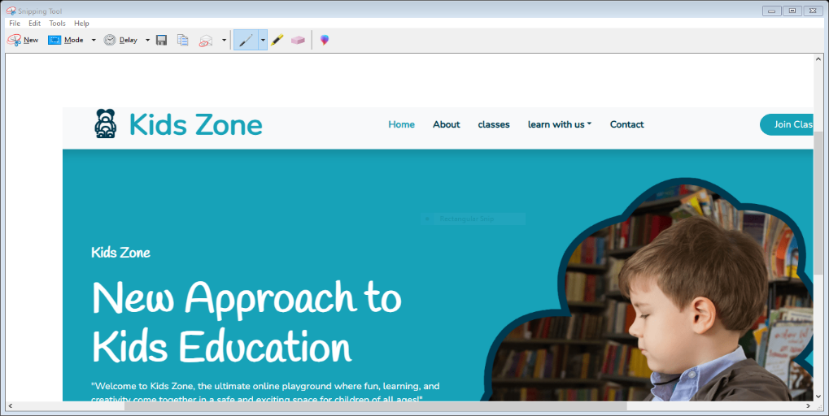

* **CODE OF HOME**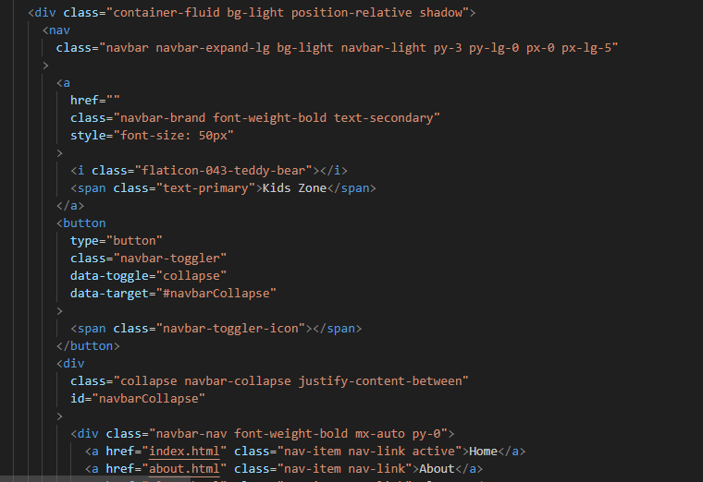
* **NAVBAR**

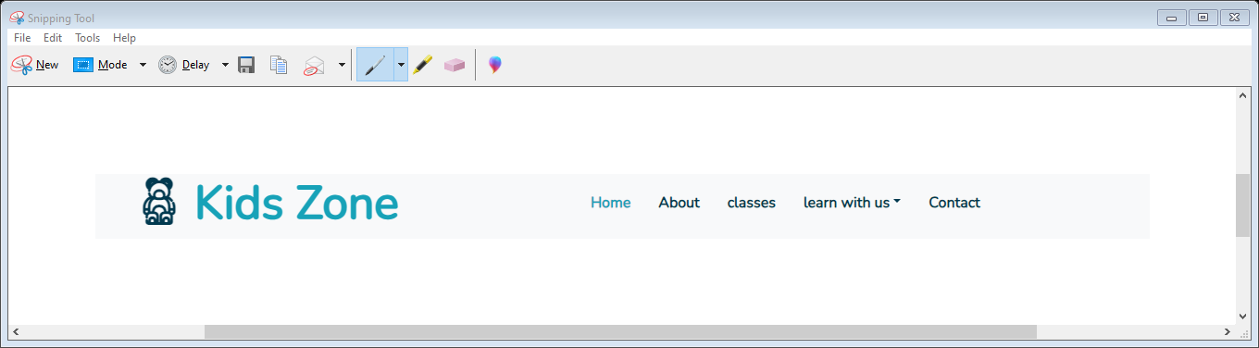

* **CODE OF NAVBAR**

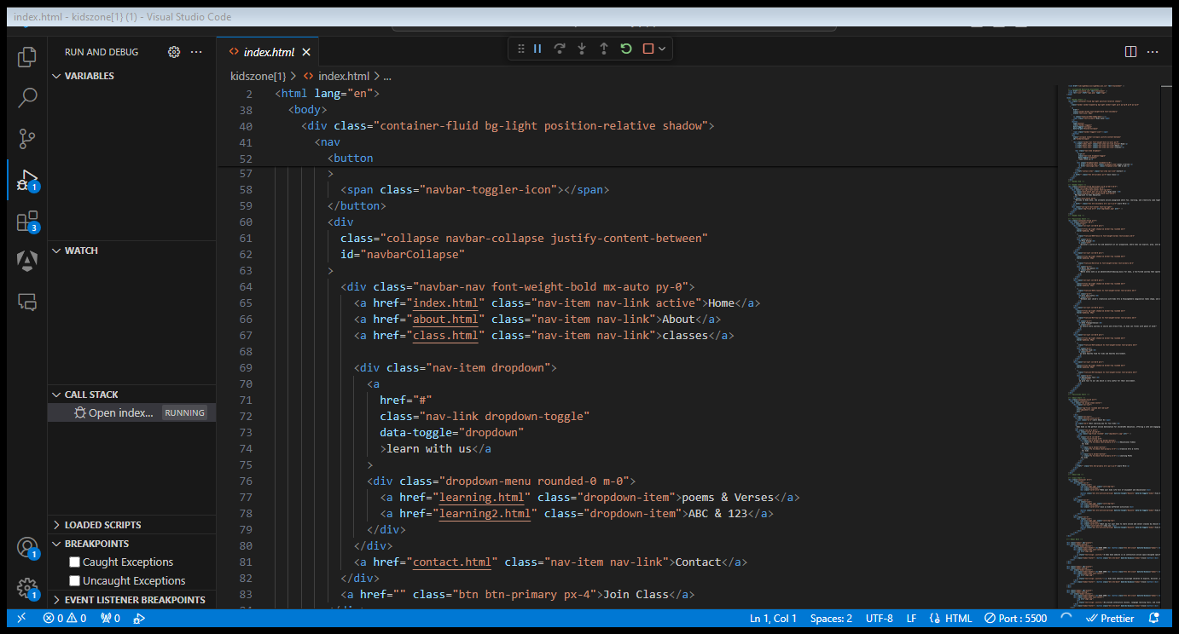

* **FOOTER**
* 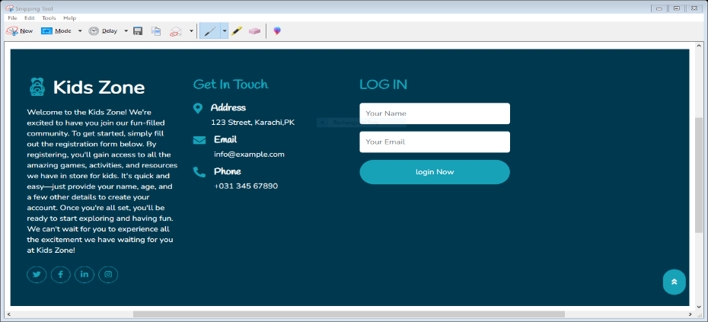
* **CODE OF FOOTER**

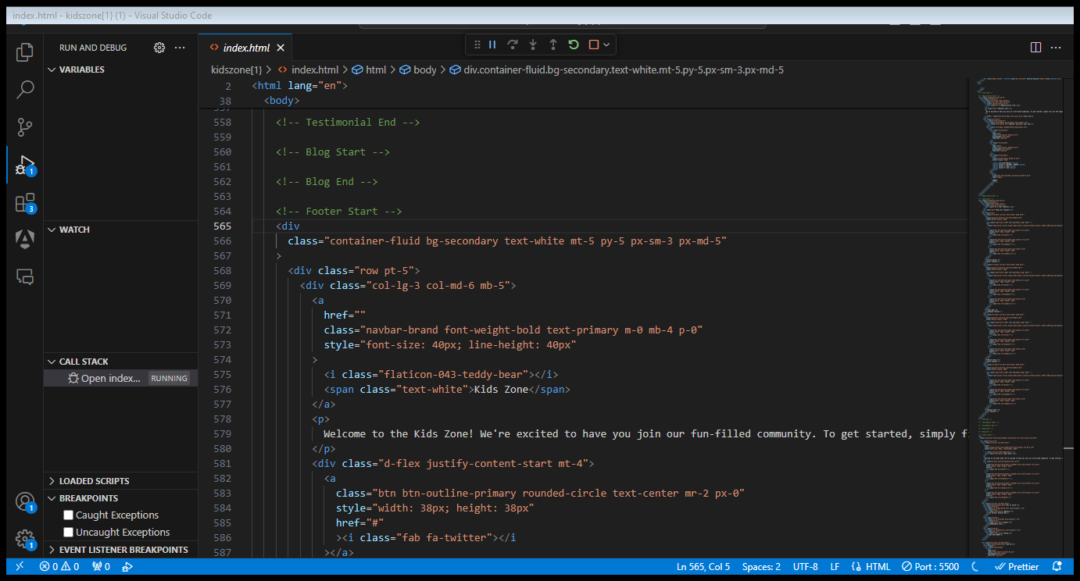

* **ABOUT US**
* 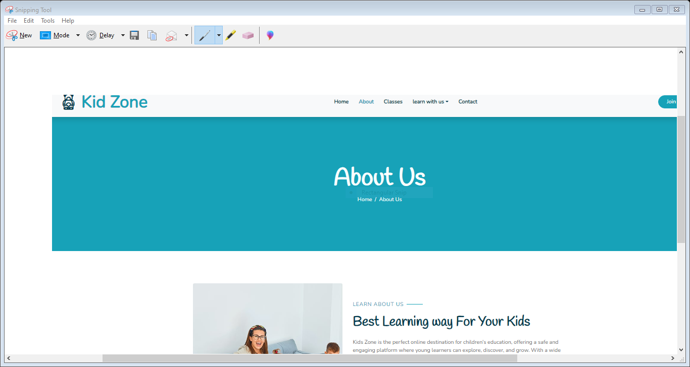
* **CODE OF ABOUT US**

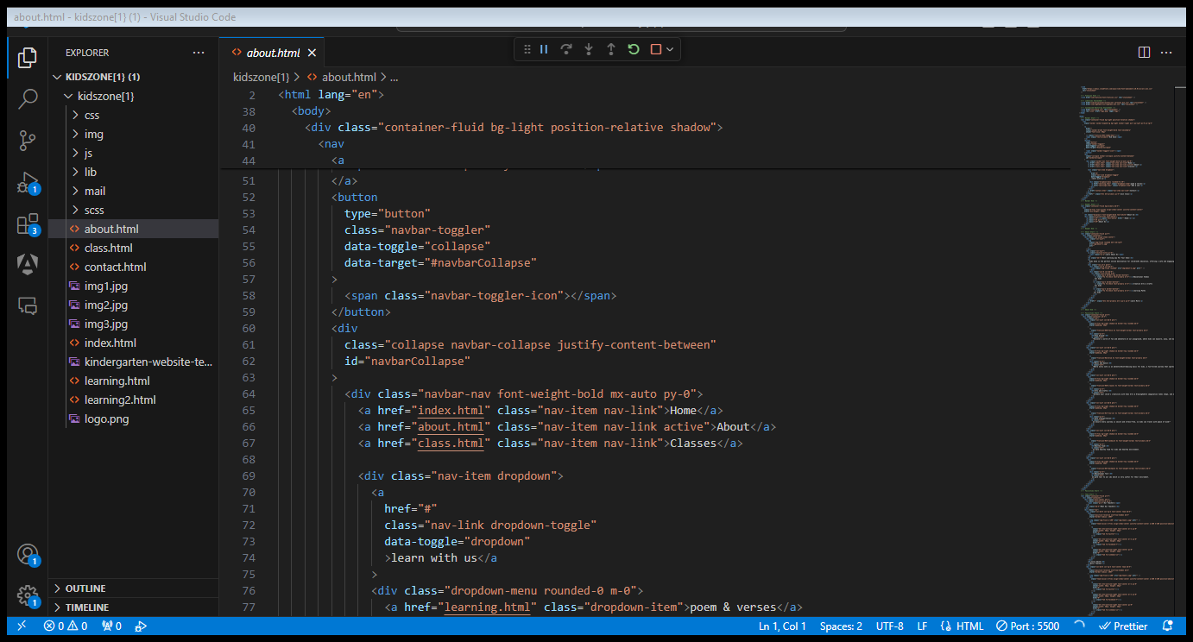

* **LEARN WITH US**
* 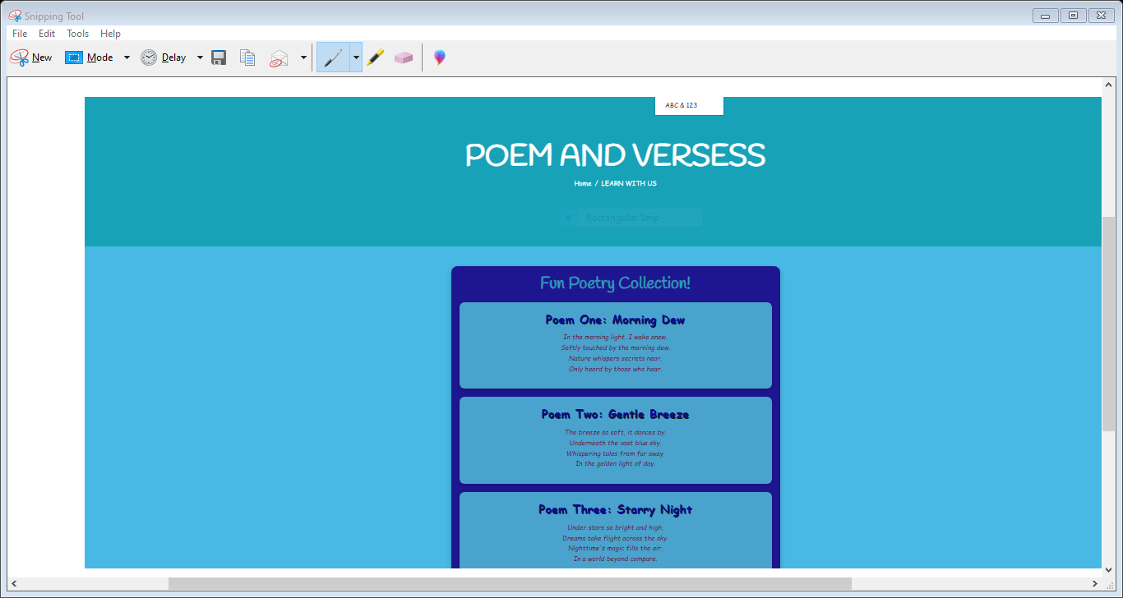
* **CODE OF LEARN WITH US**

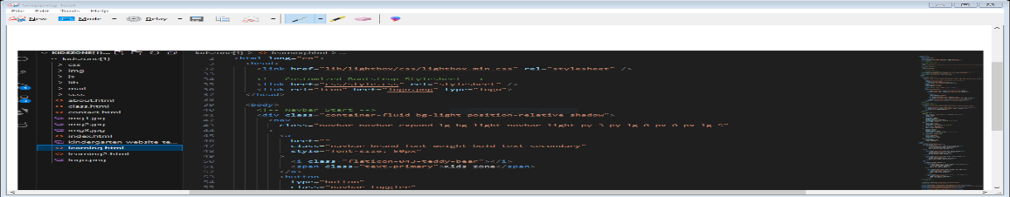

* **CONTACT US**
* 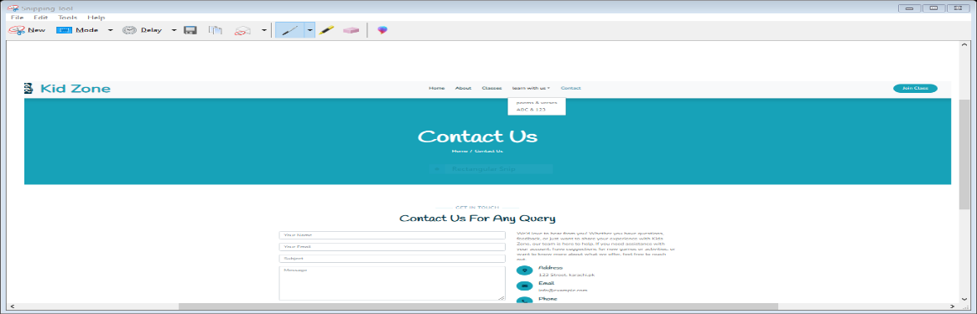
* **CODE OF CONTACT US**
* 